Instructions to load the Citrix (ICA Client) for remote access to OneChart

IMPORTANT: The ICA client MUST be loaded before you log into Citrix, if not then this could be the issue. Be sure to load the Citrix ICA client prior to logging into Citrix. Please follow the steps below to ensure you have done each step.

Using Internet Explorer, go to access.ssfhs.org (this is the SF Citrix website).
Tip! Make access.ssfhs.org a favorite on your internet explorer toolbar.

Look at top left of black log in screen for System Messages. Click on System Messages
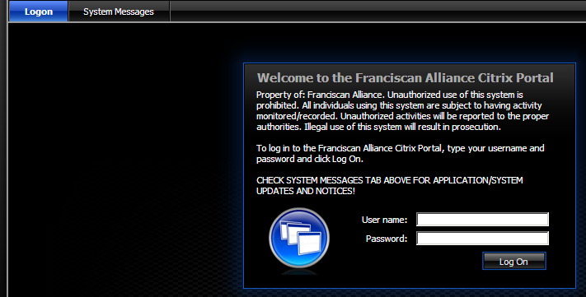
If message appears in Message Center stating “You do not have the Citrix ICA Client (Plug-in) for 32-bit Windows installed” Follow steps below:

- Users may see a System Message (Yellow Triangle on Message Bar).
- Click the System Messages to show the details.
- Click on the link "Click here to obtain plug-in"
- Click on the selection box to activate the download button.
- Click on the Download button to begin the process of the download.
- Click on Run.
- Wait while the plug-in installation files are downloaded to the workstation.
- Click on the Run button to begin the install of the Citrix Web Plug-in.
- Wait until the "Installation completed successfully" message is displayed.
- CLOSE your browser \ session.
- Open a new browser\ session.
- Point browser\session to access.ssfhs.org
- Now you can log in using your id\password
- Click on the Epic PRD East icon to access OneChart. Log in with the same user id and password.
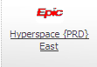
Always go to access.ssfhs.org for Citrix access to OneChart

